**Conservation scenarios**

We simulated four protected area network development strategies derived from four conservation theories described in the literature and enacted by conservation and land management agencies globally (Murdoch et al. 2007, Burkey 1989, Hjort et al. 2015).

*Economic*

One conservation strategy we assessed sought to maximize conservation return on investment (Polasky et al. 2008). This strategy emphasizes that economic costs should be balanced with intended biodiversity benefits when evaluating conservation action (hereafter, referred to as the economic strategy) (Robillard and Kerr 2017). For this protected area strategy, we focused on the acquisition of lower cost parcels of land allowing us to conserve 25% more land at each time step. We simplified the conservation return on investment framework, which usually incorporates metrics of biodiversity and/or habitat quality in addition to economic data when assessing where to invest for the greatest return. Rather, we considered the ability to acquire additional land for conservation to represent increased conservation return on investment. For the economic strategy, we used parcel valuation data from the NC OneMap geoportal to calculate cost per acre across the study extent and used zonal statistics in ArcMap 10.6 to assign an average cost per acre to individual forest stands (NC OneMap 2019, ESRI 2018). Hoke County was excluded from this analysis because it did not have parcel value data assigned, and any stands with a zero total dollar value were removed from consideration for acquisition. We then did a weighted random sort with stands of the lowest cost per acre having the highest probability of being selected. At each time step, stands were selected for acquisition and restoration based on this sort until approximately 1.25% of the total landscape amount was reached at each time step. Sorted stands are listed in the Econ_parcels_prob_ord_100.csv file in this folder.

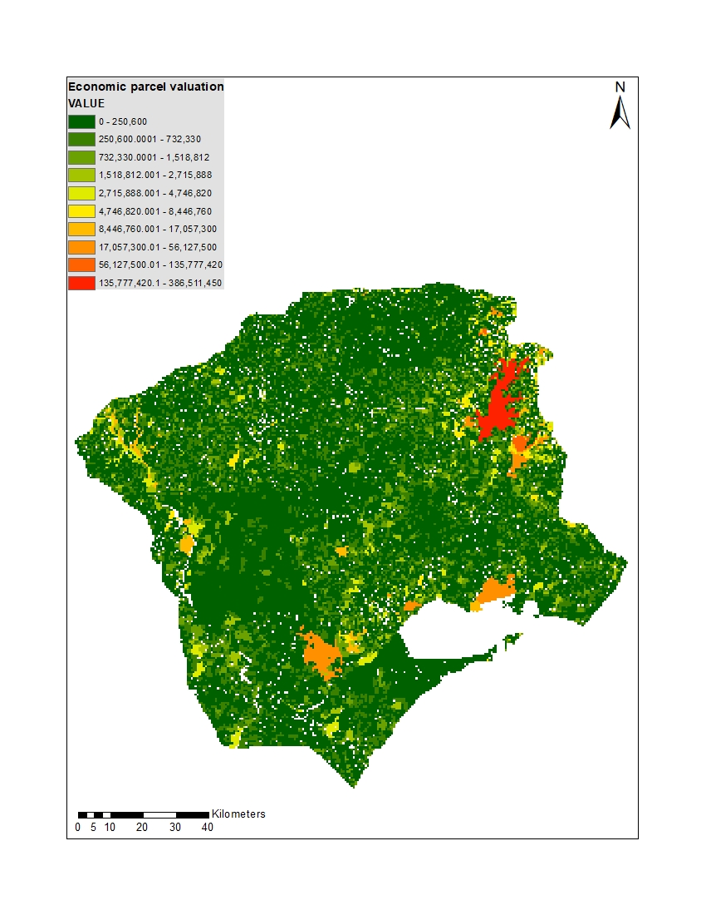

*Cluster*

Another conservation strategy we evaluated was clustering protected area development around already established conservation cores (hereafter, the cluster strategy), essentially creating larger core areas of protected habitat. This strategy reflects the SLOSS (single large or several small) debate in the reserve design literature, but has also been suggested as a more effective way to combat anthropogenic change than small, scattered protected areas (Diamond 1975, Maiorano et al. 2008). We created buffers at 100, 500, 1000, 2500 meters around already protected areas on our landscape identified in the US Geological Survey’s Protected Areas database (USGS 2018). Forest stands whose centers fell within the 100m buffer had the highest priority of being selected for conservation under this strategy, followed by stands that had centers within the 500m buffer, stands with centers in the 1000m buffer, and finally, stands with centers in the 2500m buffer. Stands that fell outside of these three buffers had the lowest probability of selection. We then conducted a weighted random sort and at each time step, stands were selected for acquisition and restoration until approximately 1% of the total landscape amount was protected at each time step. Sorted stands are listed in the stands_cluster100.csv file in this folder.

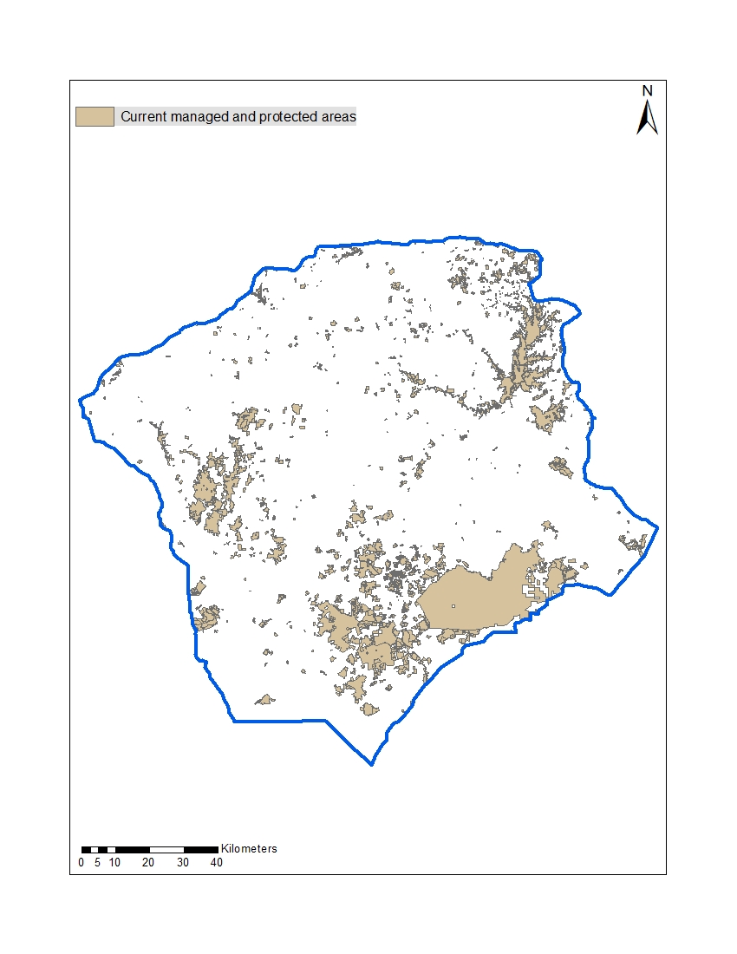

*Geodiversity*

The third conservation strategy we evaluated was conserving land with the highest geodiversity characteristics, a proxy for the ‘conserving nature’s stage’ theory (Lawler et al. 2015) (hereafter, geodiversity). The term geodiversity encompasses the natural range of variation in geological, geomorphological, and soil characteristics on a landscape (Gray 2008). High geodiversity in a landscape often means more environmental niches, resulting in higher levels of overall biodiversity (Comer et al. 2015). Prioritizing geodiversity in conservation has also been suggested as a strategy resilient to climate change, as sites with high geodiversity have greater capacity to maintain species diversity and ecological function as the climate changes (Anderson et al. 2015). For the geodiversity strategy, we used geodiversity data from the Nature Conservancy’s resilient and protected landscapes map and used zonal statistics in ArcMap 10.6 to assign an average geodiversity score to each stand (TNC 2016, ESRI 2018). We then performed a weighted random sort with forest stands scoring the highest in geodiversity having the highest probability of being selected. At each time step, stands were selected for acquisition and restoration based on this sort until approximately one percent of the total landscape amount was reached at each time step. Sorted stands are listed in the stands_geo100.csv file in this folder.

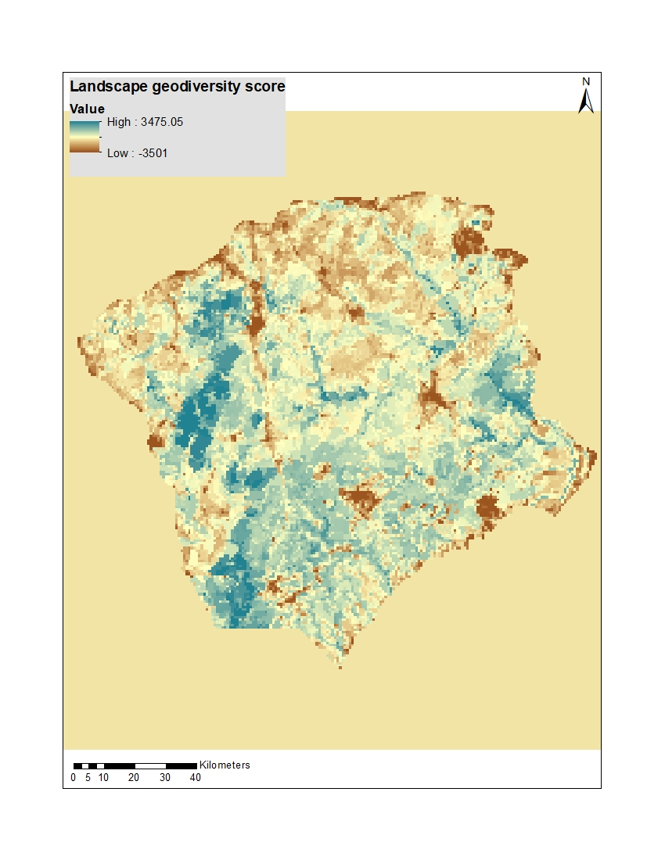

*Opportunistic*

The final conservation strategy we simulated was the opportunistic acquisition and restoration of land (hereafter, opportunistic). To do this, forest stands were randomly selected, representing the ad hoc nature of land acquisition that can sometimes occur when a parcel becomes unexpectedly available for conservation acquisition (e.g. when land is donated or voluntarily protected by easement). These stands were acquired and restored at the same rate, one percent per time step, and underwent the same restoration actions in the same proportions as the above conservation strategies. This strategy also served as a null model to compare the other conservation strategies against. Sorted stands are listed in the random_stands_base.csv file in this folder.

Citations

Polasky, S., Nelson, E., Camm, J., Csuti, B., Fackler, P., Lonsdorf, E., Montgomery, C., White, D., Arthur, J., Garber-Yonts, B., Haight, R., Kagan, J., Starfield, A., Tobalske, C. (2008). Where to put things? Spatial land management to sustain biodiversity and economic returns. Biological Conservation, 141, 1505-1524.

Robillard, C.M., Kerr, J.T. (2016). Assessing the shelf life of cost-efficient conservation plans for species at risk across gradients of agricultural land use. Conservation Biology, 31, 837-847.

NC OneMap. (2016). NC Parcel boundaries and standard fields- download. https://www.nconemap.gov/datasets/parcels-polygons

ESRI. (2018). ArcGIS Desktop: Release 10.6. Redlands, CA: Environmental Systems Research Institute.

Diamond, J.M. (1975). The island dilemma: Lessons of modern biogeographic studies for the design of natural reserves. Biological Conservation, 7, 129-146.

Maiorano, L., Falcucci, A., Boitani, L. (2008). Size-dependent resistance of protected areas to land-use change. Proceedings of the Royal Society of Biology, 275, 1297-1304.

U.S. Geological Survey (USGS) Gap Analysis Project (GAP). (2018). Protected Areas Database of the United States (PAD-US): U.S. Geological Survey data release, <https://doi.org/10.5066/P955KPLE>.

Lawler, J.J., Ackerly, D.D. , Albano, C.M., Anderson, M.G., Dobrowski, S.Z., Gill, J.L., Heller, N.E., Pressey, R.L., Sanderson, E.W., Weiss, S.B. (2015). The theory behind, and the challenges of, conserving nature’s stage in a time of rapid change. Conservation Biology, 29, 618-629

Gray, M. (2008). Geodiversity: developing the paradigm. Proceedings of the Geologists' Association, 119, 287-298.

Comer, P.J., Pressey, R.L., Hunter, M.L., Schloss, C.A., Buttrick, S.C., Heller, N.E., Tirpak, J.M., Faith, D.P., Cross, M.S., Shaffer, M.L. (2015). Incorporating geodiversity into conservation decisions. Conservation Biology, 29, 692-701.

Anderson, M.G., Comer, P.J., Beier, P., Lawler, J.J., Schloss, C.A., Buttrick, S., Albano, C.M., Faith, D.P. (2015). Case studies of conservation plans that incorporate geodiversity. Conservation Biology, 29, 680-691.

The Nature Conservancy. (2016). Resilient and connected landscapes- Resilient land layer. https://www.conservationgateway.org/ConservationByGeography/NorthAmerica/UnitedStates/edc/reportsdata/terrestrial/resilience/resilientland/Pages/default.aspx